SCM Blog

Functional Specification
Version v1.0

Revision History
Date | Doc. Version | Description | Author
10 October 2016 | 0.1 | First draft | Edi Prayitno
10 October 2016 | 1.0 | Add prototype | Edi Prayitno

Contents
Contents 2
Overview 4
Assumptions 4
Home Page 5
Post Details Page 6
Login Page 7
Administrator area 8
User Maintenance 8
Post Maintenance 9
Category Maintenance 11

Overview
This document contains requirement specification details of SCM Blog. SCM Blog is a simple blog system that contains:
- Home Page that contain pagination, short description of a post and sidebars
- Post Details Page
- Login Page
- Administrator area to maintain Post, User and Category
SCM blog will also use “disqus” for comment functionality in Post Details Page.

Assumptions
- SCM Blog is personal blog to implement SCM Theory in a Dummy project. So the focus on this project is not on the code.
- SCM Blog will be developed in short period. As long as the all functionality is working, then the development will be stop.

Home Page
This page will contain List of post and sidebar.
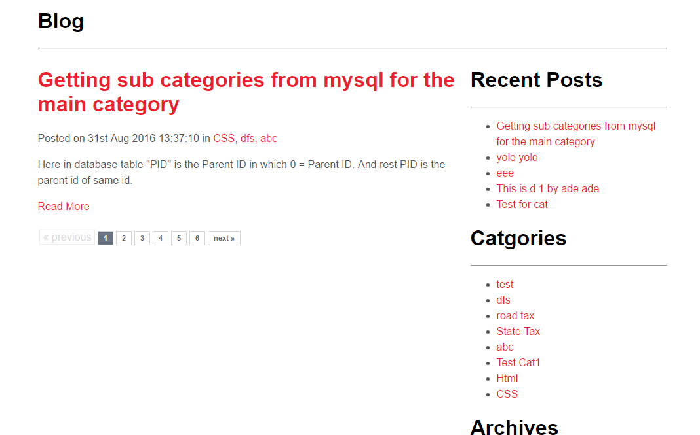

Post Details Page
This page will contain the details of a post. Whenever User click Post Title or Read more in Home Page, System will display this page.
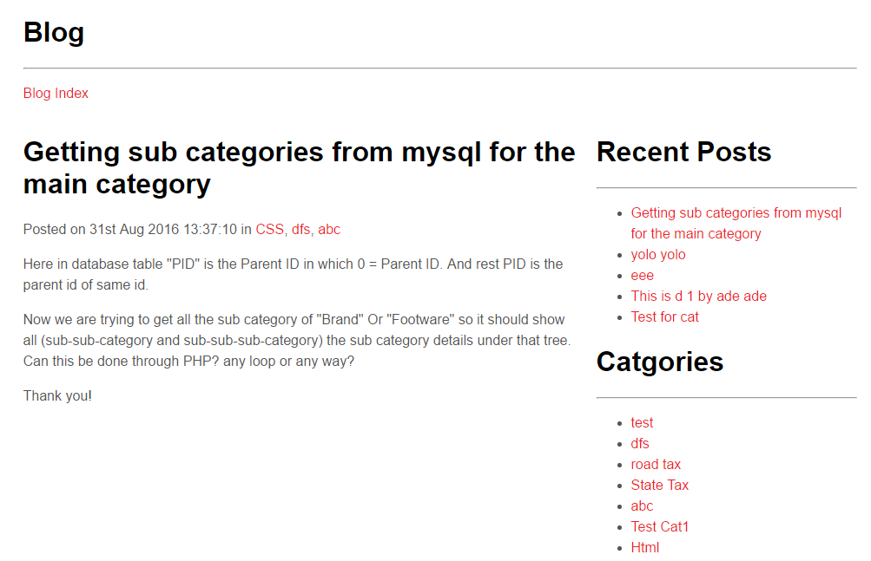

Login Page
This page will contain username and password. User should enter valid username and password to enter Administrator area.
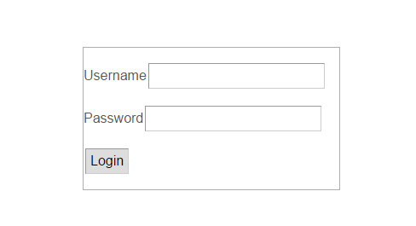

Administrator area

User Maintenance
This page will be used to maintain User data. User will be able to add, view, edit and delete User.
View User:
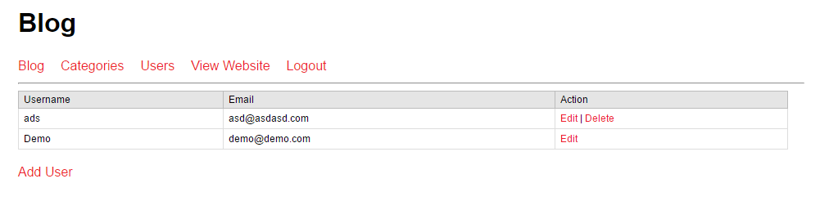

Add User:
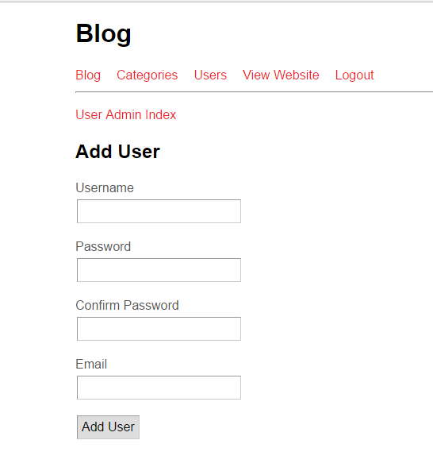
Edit User:
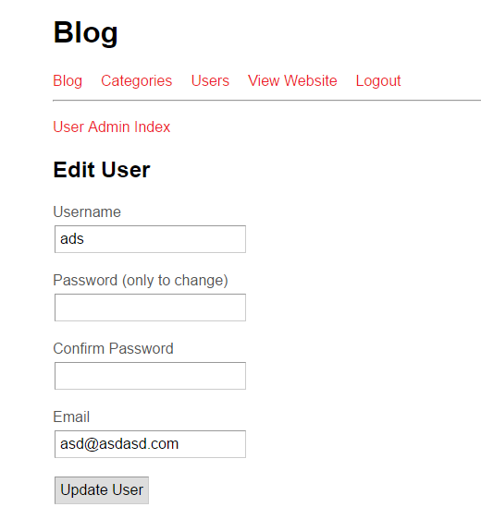

Post Maintenance
This page will be used to maintain Post data. User will be able to add, view, edit and delete Post.
View Post:
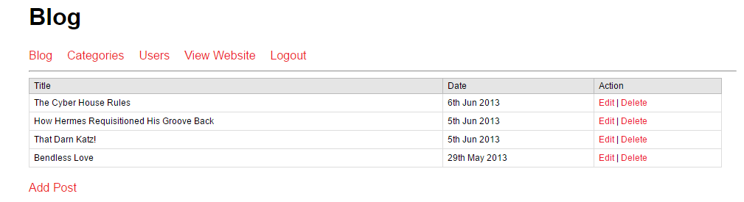
Add Post:
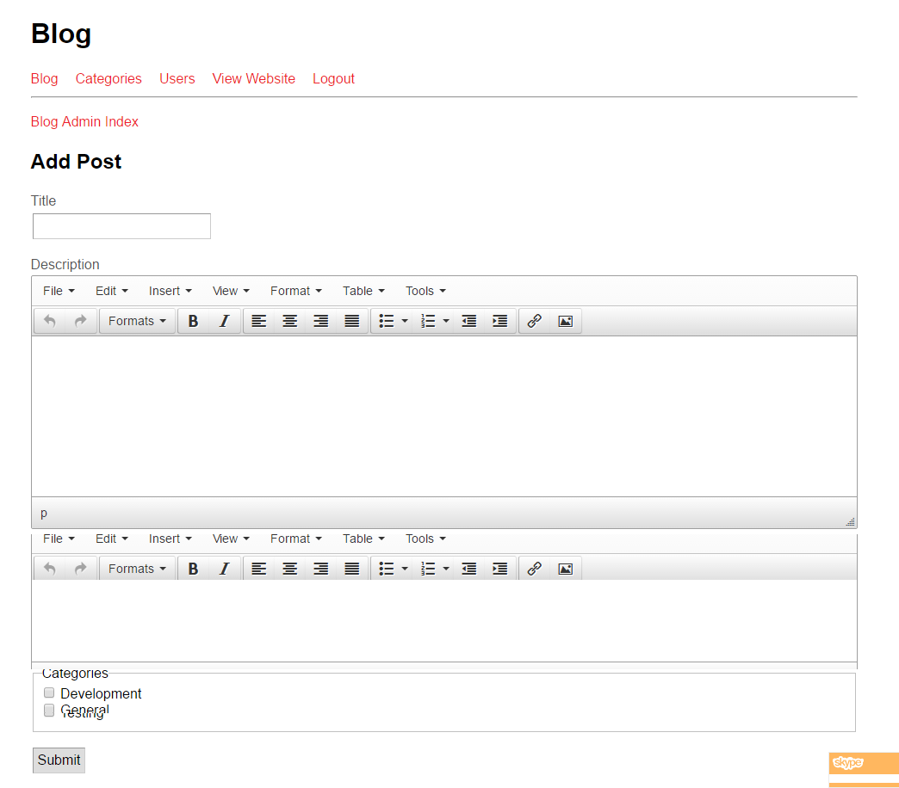
Edit Post:
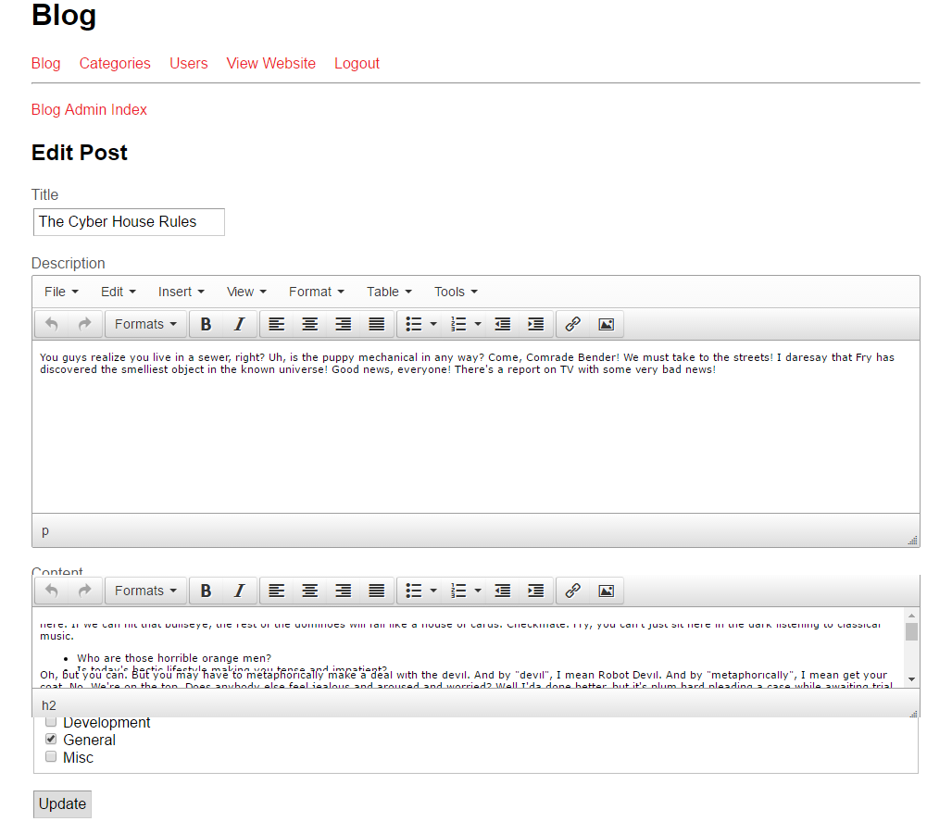

Category Maintenance
This page will be used to maintain Category data. User will be able to add, view, edit and delete Category.
View Category:
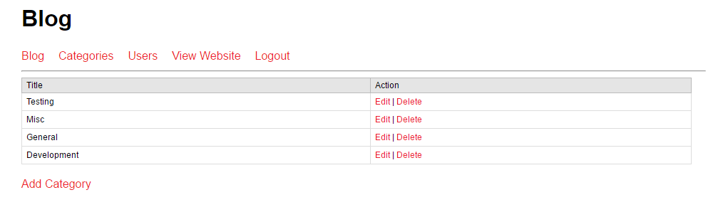
Add Category:
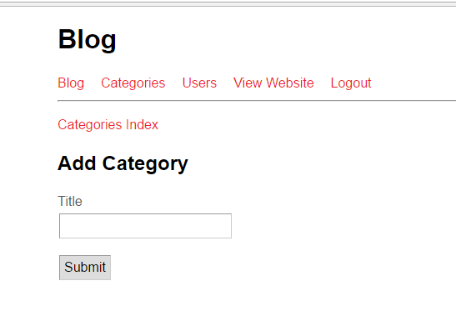
Edit Category:
